HackerRank - Staircase
Code:
#include <stdio.h>
int main() {
int n;
scanf("%d", &n);
for (int i = 1; i <= n; i++) {
for (int j = 1; j <= n - i; j++) {
printf(" ");
}
for (int k = 1; k <= i; k++) {
printf("#");
}
printf("\n");
}
return 0;
}

Screenshot: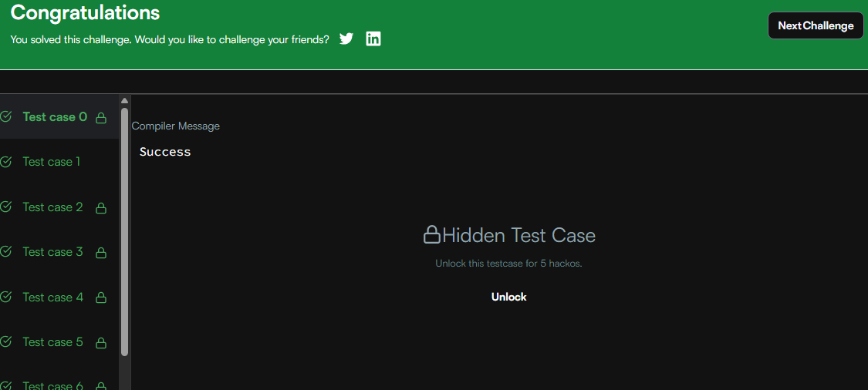

Link:
https://www.hackerrank.com/challenges/staircase/problem

